Name: ________________________________ Date:
A Time of Reform (1812-1860)
During 1812-1860, the United States saw the rise of four major movements take place that sought to change American society:
1. A Religious Movement
2. The Temperance Movement
3. The Anti-Slavery Movement
4. The Women’s Movement

1. Religious Movement
- Known as the “Second Great Awakening” (the first one occurred during the early 1700s when America was still the 13 Colonies), there was a sudden “burst” of energy about an enthusiastic religious movement which swept America in the early-mid 1800s. Americans became more serious about religion, church membership skyrocketed, and Americans tried to life their lives in with an increased emphasis on morality and decency. As a result, the early-mid 1800s saw widespread campaigns across the country to help reform, or improve things such as the education and school system, along with the prison system, and the better treatment towards mentally ill and imprisoned citizens.

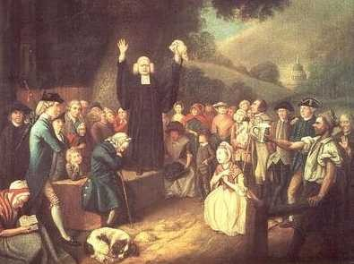
2. Temperance Movement
The temperance movement of the mid-late 1800s was an organized effort to encourage moderation, or restraint, when it came to the consumption of alcohol. The movement was an offshoot of the “Second Great Awakening”, and was mostly led by women who, with their children, had endured the effects of uncontrolled drinking by their husbands. In fact, alcohol was blamed for many of society's faults, including severe health problems, poverty and crime. The movement had mild success, getting about 12 states to pass laws restricting or limiting the sale of alcohol.

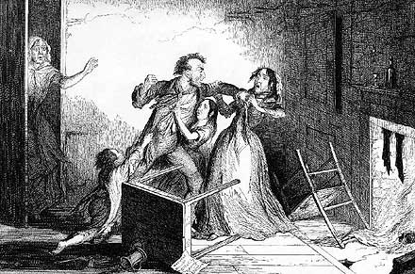
3. Anti-Slavery Movement (Abolitionist Movement)
- Many Americans, influenced greatly by the teachings of living morally and decently, began shifting their focus to helping another group of people in the country who were being exploited: African Americans. There were often slave rebellions, or uprisings, specifically one led by Nat Turner in 1831. Those who fought to end slavery and free all of the 2 million+ slaves (the amount by 1830), were called abolitionists. Some abolitionists were white, including Boston printer William Lloyd Garrison who founded a newspaper called The Liberator which was devoted to abolishing slavery. Others were black, some of whom were escaped slaves who became Freedmen, such as Frederick Douglass, who traveled the North speaking out against slavery and eventually wrote an autobiography in 1845 which was detailed how gruesome slavery was. Douglass went on to become an adviser to President Abraham Lincoln.

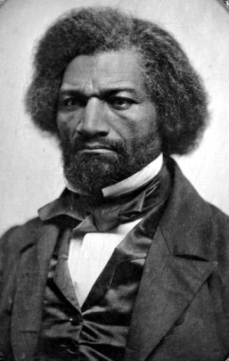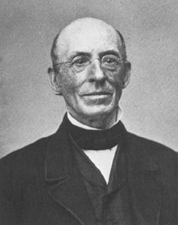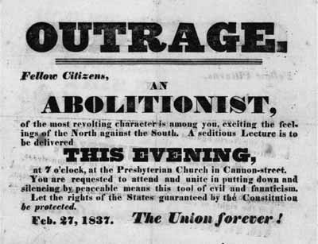

4. Women’s Movement
- In the 1800s, American women’s freedoms and rights were severely limited. Also influenced by the Second Great Awakening, women of the early-mid 1800s began to take on more active roles in public life. In the early 1800s, women could not vote, hold public office, serve on juries, receive any level of “higher education”, could not work in most professions, could not sue for divorce, gain custody of children and lost property they owned when they married. In 1848, however, there was a major breakthrough. At the Seneca Falls Convention (in NY), Elizabeth Cady Stanton & Lucretia Mott helped organize the nation’s first Women’s Rights Convention. The Convention paved the way for women to gradually acquire more rights, including the right to vote in 1920.
