# LIFE_logo_2935_w_type_New_School

# NYS Basic Skills Social Studies Exam

Name:\_\_\_\_\_\_\_\_\_\_\_\_\_\_\_\_\_\_\_\_\_\_\_\_\_\_\_\_\_\_ Instructor:\_\_\_\_\_\_\_\_\_\_\_\_\_\_\_\_\_\_\_\_\_\_\_\_\_\_\_\_\_\_\_\_

Date:\_\_\_\_\_\_\_\_\_\_\_\_\_\_\_\_\_\_\_\_\_\_\_\_\_\_\_\_\_\_\_ Class:\_\_\_\_\_\_\_\_\_\_\_\_\_\_\_\_\_\_\_\_\_\_\_\_\_\_\_\_\_\_\_\_\_\_\_\_

This test assesses and checks your understanding of basic social studies, geography, civics, and history questions. Please answer all questions to the best of your abilities.

1. How many states are there in the United States?
   1. 13
   2. 25
   3. 50
   4. 18
2. How many stars are there on our flag?
   1. 16
   2. 50
   3. 25
   4. 13
3. What are the only 2 states that are ***not*** ***physically*** connected to the United States?
   1. Montana and New Jersey
   2. California and Minnesota
   3. Delaware and New Hampshire
   4. Hawaii and Alaska
4. Where is our nation’s capital located?
   1. Washington, D.C.
   2. New York City
   3. Philadelphia
   4. Boston
5. What is the capital of New York State?
   1. Manhattan
   2. Albany
   3. Buffalo
   4. New York City
6. Which country is directly ***north*** of the United States?
   1. Canada
   2. Africa
   3. Puerto Rico
   4. Australia
7. Which county is directly ***south*** of the United States?
   1. Colorado
   2. South Dakota
   3. Europe
   4. Mexico
8. What type of government does the United States have?
   1. Monarchy
   2. Democracy
   3. Theocracy
   4. Monopoly
9. What is the minimum voting age in the United States?
   1. 8
   2. 21
   3. 18
   4. 25
10. What are the 3 colors of our flag?

\_\_\_\_\_\_\_\_\_\_\_\_\_\_\_\_\_\_\_\_\_\_\_\_\_\_\_\_\_\_\_\_\_\_\_\_\_\_\_\_\_\_\_

1. What does U.S.A. stand for?

\_\_\_\_\_\_\_\_\_\_\_\_\_\_\_\_\_\_\_\_\_\_\_\_\_\_\_\_\_\_\_\_\_\_\_\_\_\_\_\_\_\_\_\_\_\_\_\_\_\_\_

1. Is the United States a country or a continent?

\_\_\_\_\_\_\_\_\_\_\_\_\_\_\_\_\_\_\_\_\_\_\_

1. On which coast is New York located on?

\_\_\_\_\_\_\_\_\_\_\_\_\_\_\_\_\_\_\_\_\_\_\_

1. What is the name of the ocean on Americas ***east*** coast?

\_\_\_\_\_\_\_\_\_\_\_\_\_\_\_\_\_\_\_\_\_\_\_\_\_\_\_\_\_\_\_\_\_

1. What is the name of the ocean on Americas ***west*** coast?

\_\_\_\_\_\_\_\_\_\_\_\_\_\_\_\_\_\_\_\_\_\_\_\_\_\_\_\_\_\_\_\_\_

1. How many continents are there in the world? \_\_\_\_\_\_\_
2. What is the name of the Presidents official home known as?

\_\_\_\_\_\_\_\_\_\_\_\_\_\_\_\_\_\_\_\_\_\_\_\_\_\_\_\_\_\_\_\_\_\_\_

1. Who was the first president of the United States?

\_\_\_\_\_\_\_\_\_\_\_\_\_\_\_\_\_\_\_\_\_\_\_\_\_\_\_\_\_\_\_\_\_\_\_\_

1. Who is our current president (today)?

\_\_\_\_\_\_\_\_\_\_\_\_\_\_\_\_\_\_\_\_\_\_\_\_\_\_\_\_\_\_\_\_\_\_\_\_

1. Why does the U.S. celebrate the Fourth of July (what are we celebrating)?

\_\_\_\_\_\_\_\_\_\_\_\_\_\_\_\_\_\_\_\_\_\_\_\_\_\_\_\_\_\_\_\_\_\_\_\_\_\_\_\_\_\_\_\_\_\_\_\_\_\_\_\_\_\_\_\_\_\_\_\_\_\_\_\_\_\_\_\_\_\_\_\_

\_\_\_\_\_\_\_\_\_\_\_\_\_\_\_\_\_\_\_\_\_\_\_\_\_\_\_\_\_\_\_\_\_\_\_\_\_\_\_\_\_\_\_\_\_\_\_\_\_\_\_\_\_\_\_\_\_\_\_\_\_\_\_\_\_\_\_\_\_\_\_\_

1. Who was Abraham Lincoln?

\_\_\_\_\_\_\_\_\_\_\_\_\_\_\_\_\_\_\_\_\_\_\_\_\_\_\_\_\_\_\_\_\_\_\_\_\_\_\_\_\_\_\_\_\_\_\_\_\_\_\_\_\_\_\_\_\_\_\_\_\_\_\_\_\_\_\_\_\_\_\_\_\_

\_\_\_\_\_\_\_\_\_\_\_\_\_\_\_\_\_\_\_\_\_\_\_\_\_\_\_\_\_\_\_\_\_\_\_\_\_\_\_\_\_\_\_\_\_\_\_\_\_\_\_\_\_\_\_\_\_\_\_\_\_\_\_\_\_\_\_\_\_\_\_\_\_

1. What major event took place on September 11, 2001?

\_\_\_\_\_\_\_\_\_\_\_\_\_\_\_\_\_\_\_\_\_\_\_\_\_\_\_\_\_\_\_\_\_\_\_\_\_\_\_\_\_\_\_\_\_\_\_\_\_\_\_\_\_\_\_\_\_\_\_\_\_\_\_\_\_\_\_\_\_\_\_\_\_

\_\_\_\_\_\_\_\_\_\_\_\_\_\_\_\_\_\_\_\_\_\_\_\_\_\_\_\_\_\_\_\_\_\_\_\_\_\_\_\_\_\_\_\_\_\_\_\_\_\_\_\_\_\_\_\_\_\_\_\_\_\_\_\_\_\_\_\_\_\_\_\_\_

**Matching:** *Please match up the questions using one answer from the word bank below. Cross out each answer that you use in order to avoid using an answer more than once. There will be one extra answer left over.*

**The Supreme Court / A document listing the country’s laws / religious freedom / Native Americans / the Bill of Rights / the Mayflower / Civil Rights leader / immigration / Christopher Colombus**

1. What are the ﬁrst 10 amendments to the Constitution called?

\_\_\_\_\_\_\_\_\_\_\_\_\_\_\_\_\_\_\_\_\_\_\_\_\_\_\_\_\_\_\_\_\_\_\_\_\_\_\_\_\_\_

1. Why did the Pilgrims come to America?

\_\_\_\_\_\_\_\_\_\_\_\_\_\_\_\_\_\_\_\_\_\_\_\_\_\_\_\_\_\_\_\_\_\_\_\_\_\_\_\_\_\_

1. What is the Constitution of the United States?

\_\_\_\_\_\_\_\_\_\_\_\_\_\_\_\_\_\_\_\_\_\_\_\_\_\_\_\_\_\_\_\_\_\_\_\_\_\_\_\_\_\_

1. What is the name of the ship that brought the Pilgrims to America?

\_\_\_\_\_\_\_\_\_\_\_\_\_\_\_\_\_\_\_\_\_\_\_\_\_\_\_\_\_\_\_\_\_\_\_\_\_\_\_\_\_\_

1. What is the name of the highest court of the United States?

\_\_\_\_\_\_\_\_\_\_\_\_\_\_\_\_\_\_\_\_\_\_\_\_\_\_\_\_\_\_\_\_\_\_\_\_\_\_\_\_\_\_

1. Who was Martin Luther King, Jr.?

\_\_\_\_\_\_\_\_\_\_\_\_\_\_\_\_\_\_\_\_\_\_\_\_\_\_\_\_\_\_\_\_\_\_\_\_\_\_\_\_\_\_

1. Who helped the Pilgrims survive the first difficult years in America?

\_\_\_\_\_\_\_\_\_\_\_\_\_\_\_\_\_\_\_\_\_\_\_\_\_\_\_\_\_\_\_\_\_\_\_\_\_\_\_\_\_\_

1. What was the name of the famous Explorer who set sail towards the Americas in the year1492?

\_\_\_\_\_\_\_\_\_\_\_\_\_\_\_\_\_\_\_\_\_\_\_\_\_\_\_\_\_\_\_\_\_\_\_\_\_\_\_\_\_\_

**(Test continues on next page)**



1. Fill in the 4 directions on this compass rose.

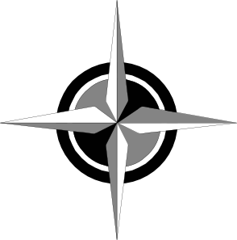

1. Which of the following pictures is of the United States?
2. 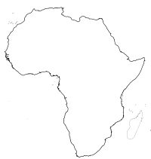
3. 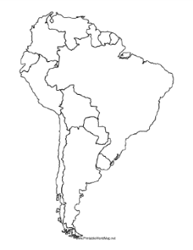
4. 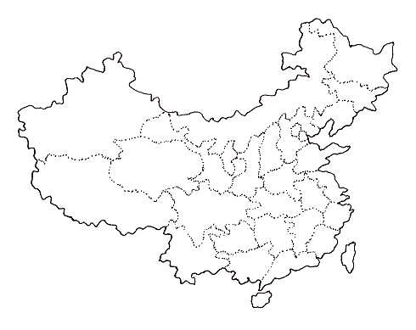
5. 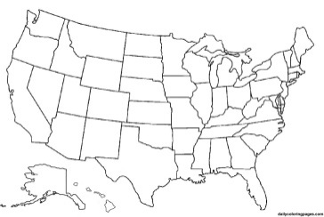

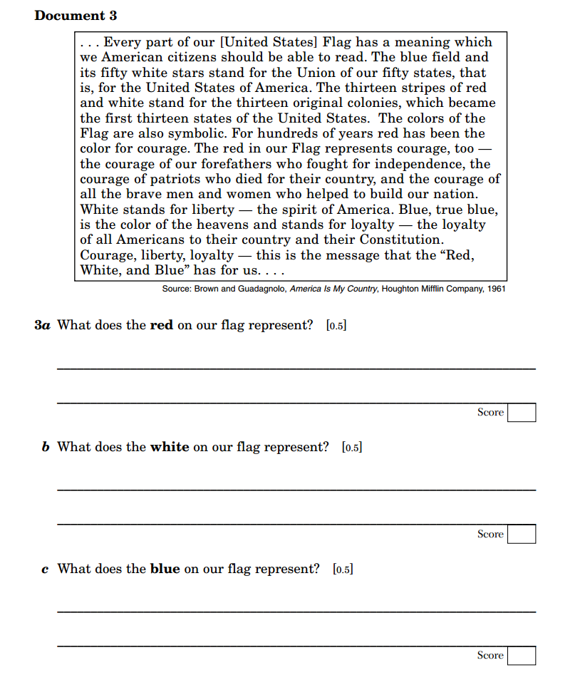

34.

